REGISTRATION FORM FOR LISTENERS

To guarantee your registration is completed on time, please note that it is essential for all participants to send in a completed registration form to g2esd@g2esd.net before July 10, 2024.
STEP 1: Please fill in the form below (Your personal information will be strictly used for the conference only).
Given Name: |  | Family Name: |  | Your photo  (Will be used on your Name Tag of the conference)
Position: Prof. ◻ Assoc. Prof. ◻ Asst. Prof. ◻ Dr. ◻ PhD Candidate ◻ Senior Lecturer ◻ Lecturer ◻ Senior Researcher ◻ Researcher ◻ Mr. ◻ Ms. ◻
Affiliation:
City: | State: | Country: | Postcode:
Telephone: | Fax: | Mobile: | Email:
Will you attend the conference in person?
Yes ◻ No ◻
Will you have meals during the conference?
1. Lunch on September 28 | Yes ◻ | No ◻
2. Dinner on September 28 | Yes ◻ | No ◻
3. Lunch on September 29 | Yes ◻ | No ◻
4. Dinner on September 29 | Yes ◻ | No ◻

Special dietary requirement
Muslim ◻ Vegetarian ◻ Gluten-free ◻ None ◻
Note: We will try our best to meet your dietary requirement, but we may not be able to meet everyone’s needs under special circumstances.

STEP 2: Please pay the registration fee
Category | Registration Fee
Listener (Standard) | 200 USD/1200 CNY
One-Day Tour on September 29th(option) | 50 USD/300 CNY
Note:
- One regular registration entitles only one person to attend the conference. If an accompanying person would like to attend the conference, it’s also suggested he/she Register as Listener
- The one-day tour fee is optional, which could be paid with the registration fee together.
- Make sure you get confirmation from the conference secretary after you submit your registration documents, in case your email slips into the spam box due to the large size of the attachment.

Listener Registration Instructions
Instructions for you if you use HCconf Conference System for listener(Guest) Registration
1. You should Create an Account Firstly.
1) Hit the link https://www.hcconf.tech/submission/g2esd-24 and then you can see the below screen:
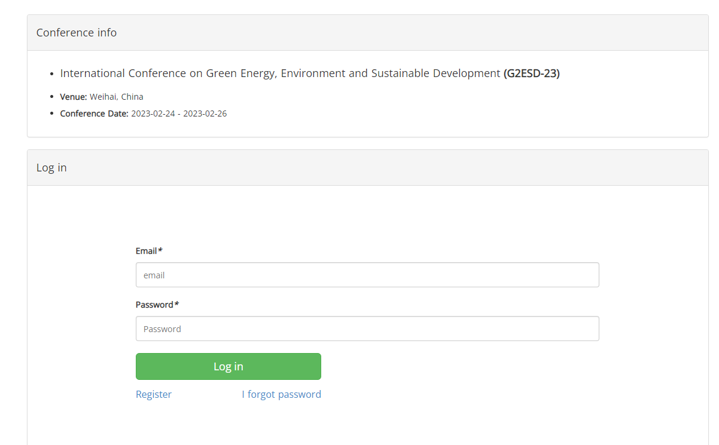
2) Click “Register” to create a new account.
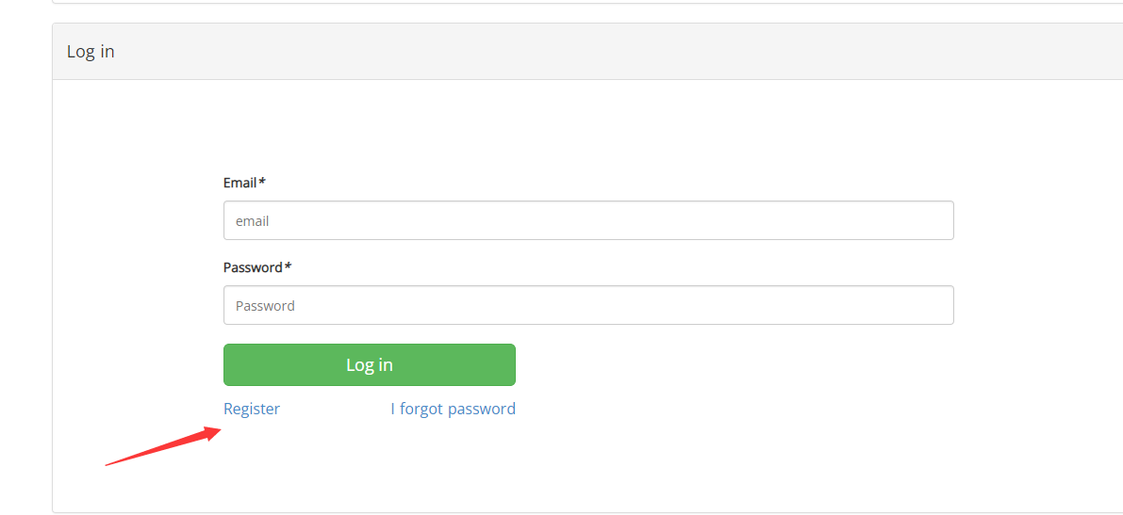

2. Log in to the HCconf Conference System with your email and password registered.
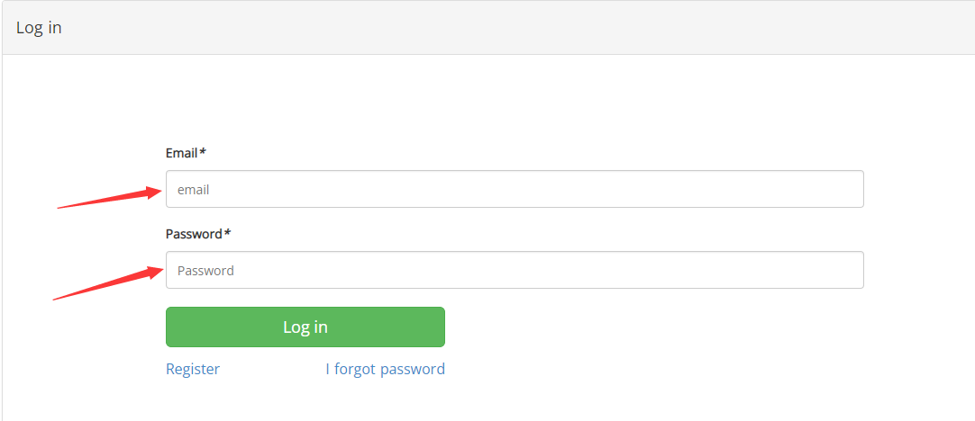
3. Get the conference that you want to register for as listener.
1) Click “My Submission” then “Submit new paper”
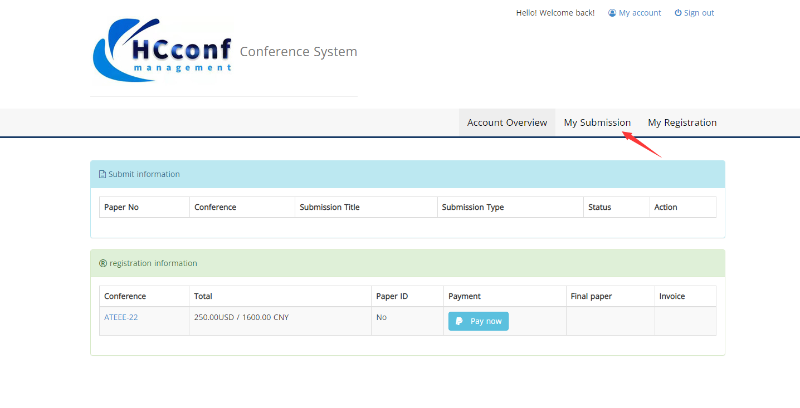
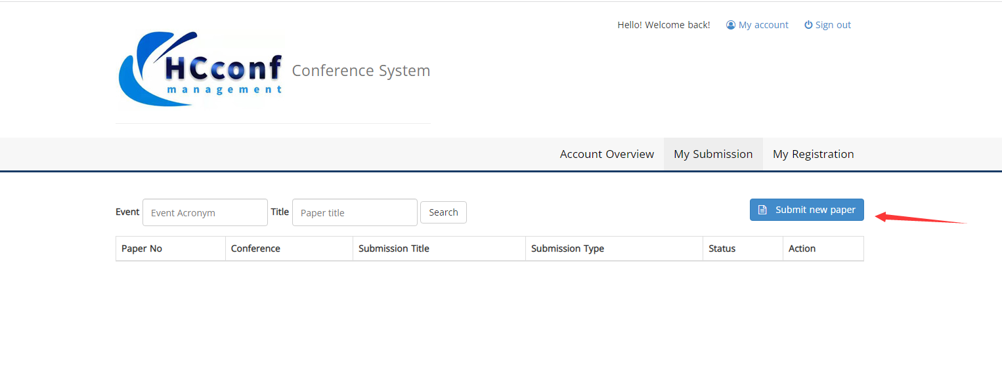

2) Search the Conference you want to register for.
Here is “ATEEE-22” for an example (Choose one of three search methods)
a. Input the abbreviation of the conference “ATEEE” in the search box and choose “abbreviation” then search.
b. Input the Full Title of the conference “International Conference on Advanced Technology of Electrical Engineering and Energy” and choose “Full Title” then search
c. Input the City of the conference “Qingdao” and choose “City” then search
3) Select the Conference you want to register for and click “Register”
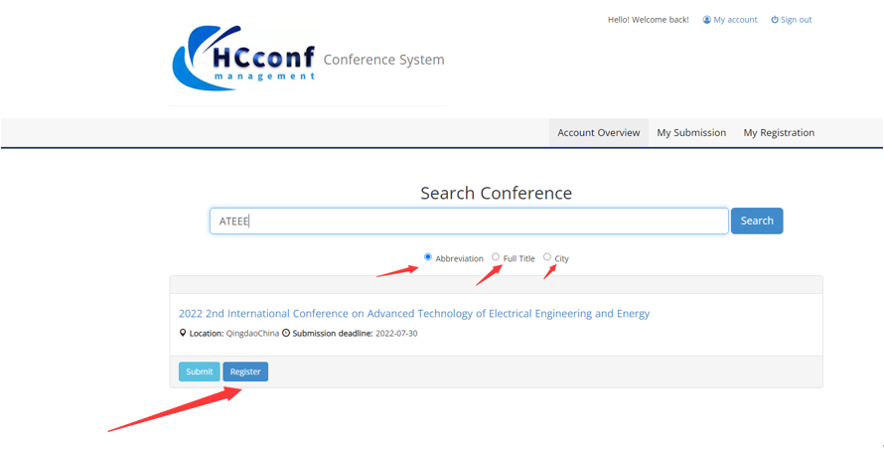
4. Fill in your registration information
Fill in the requested registration information and click “submit”.
Note: If you are not the co-author of any submitted paper, please fill in “No” in Paper No* and Paper title*; select “No submission” in Presentation Type*:

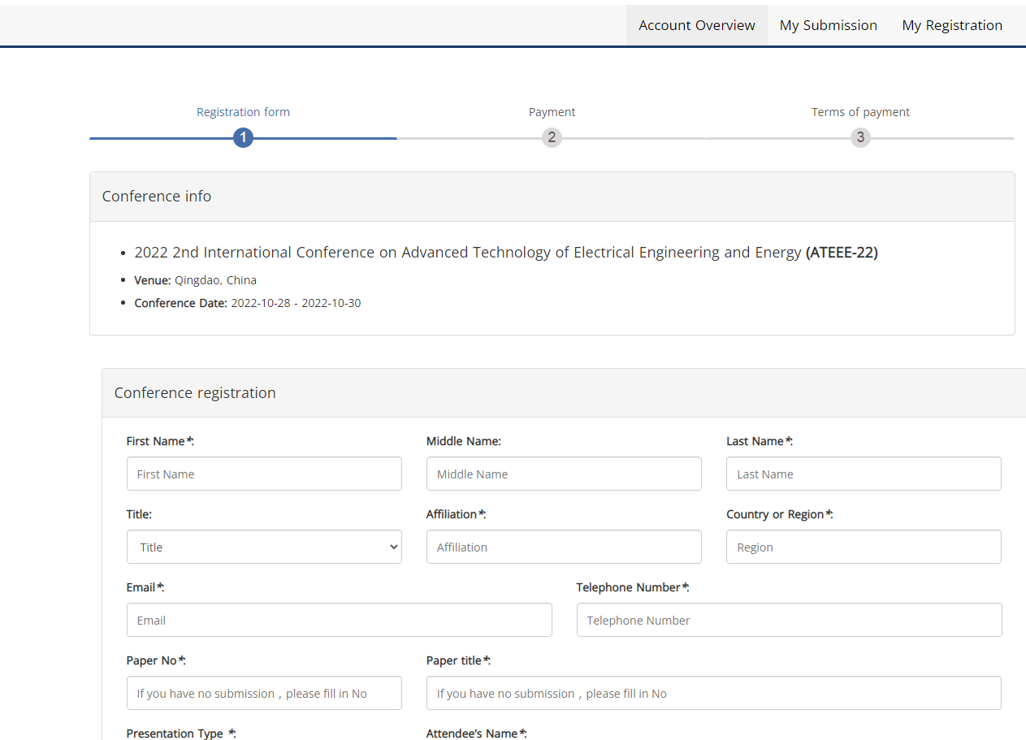

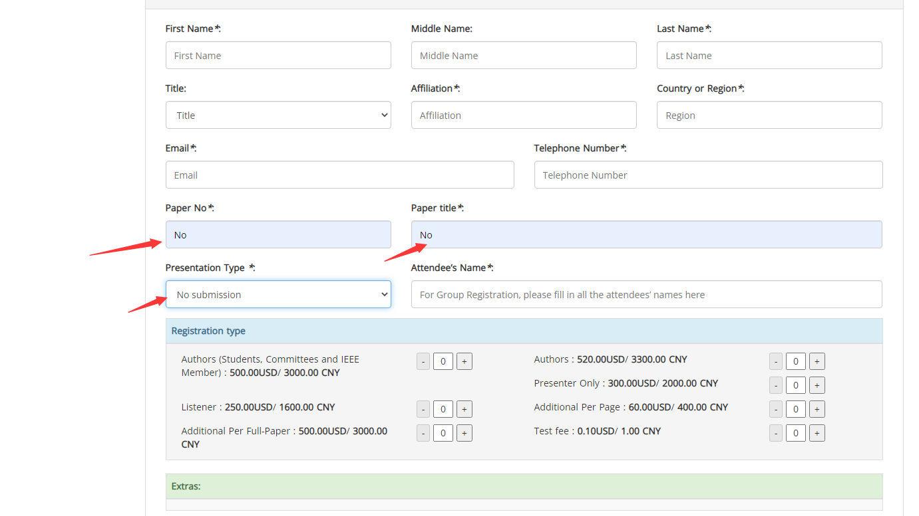

5. Registration information conformation.
Check your information; if it is wrong, click “Return and modify” or click “Confirm, submit”.
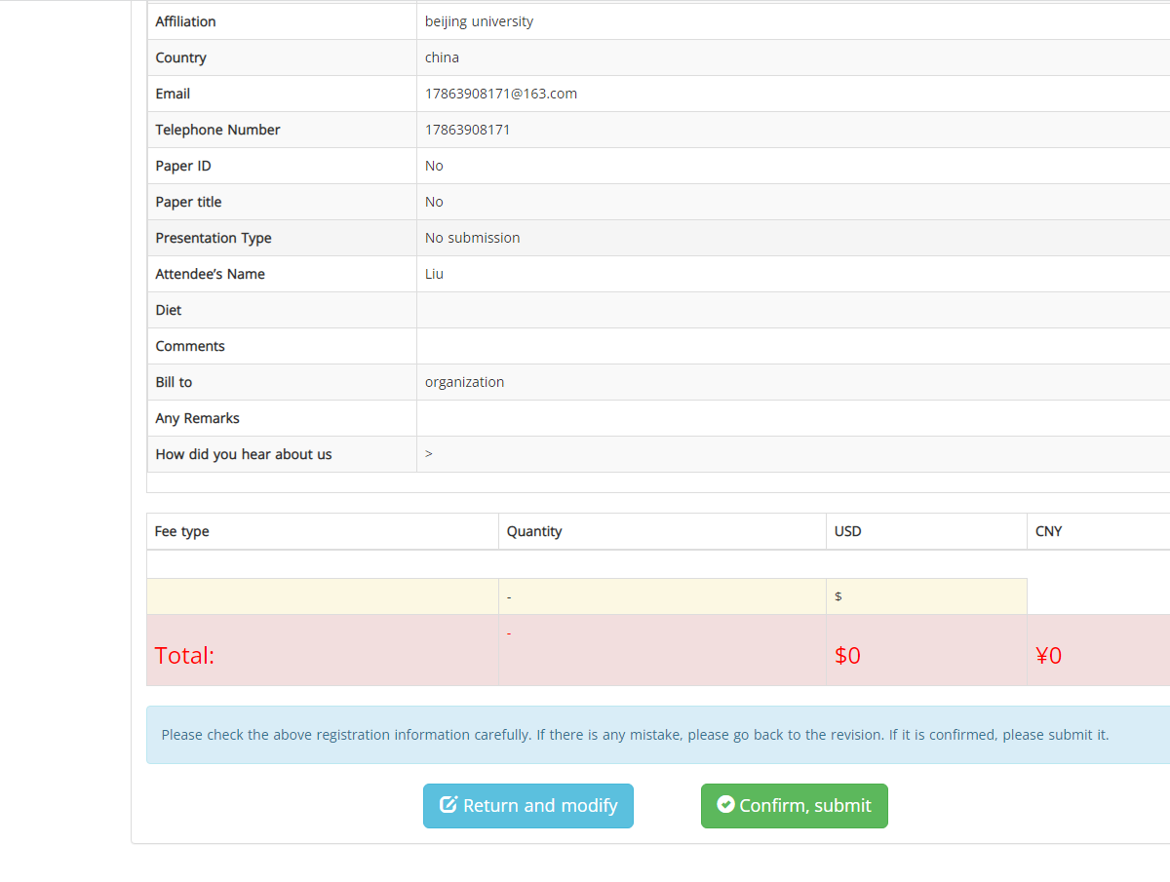
7. Make the payment to complete registration.
Choose one of the payment methods to complete the registration. Paypal(Credit Card) is the best way to pay in USD for the register from out of China Mainland
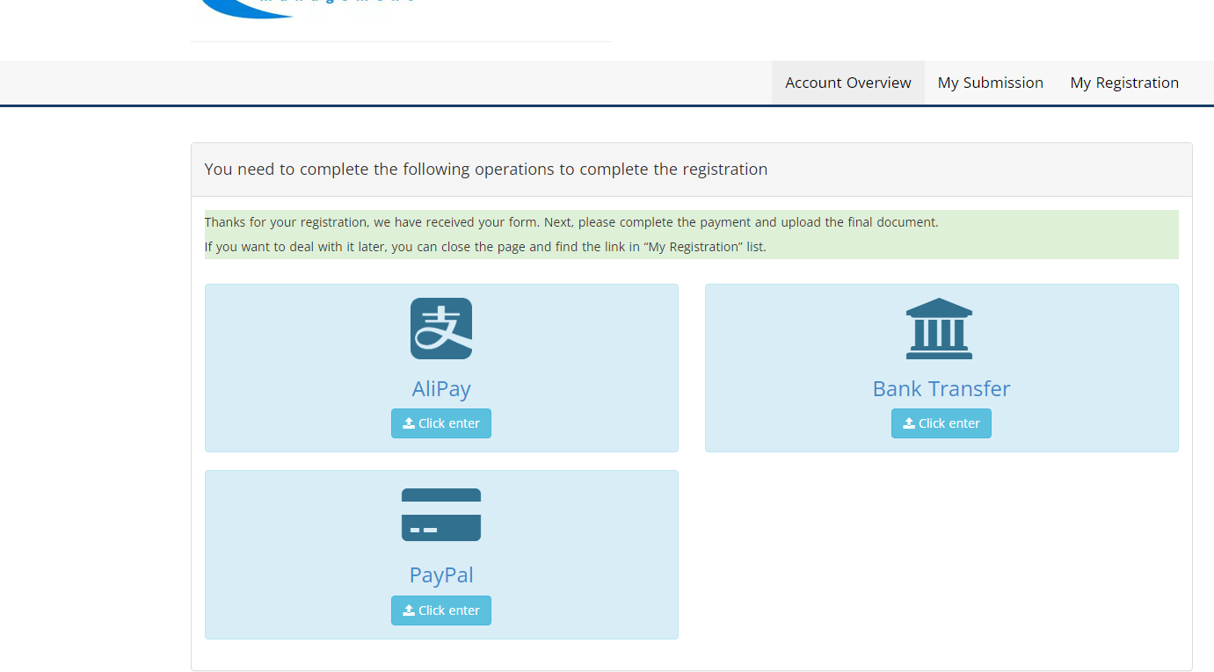
------------------------------------------------------------------------------------------------------------------
End of Instructions. Thank you!

